

Year 12 ATAR Physics
Unit 3 Semester 1 2024
Electromagnetism Test

Student Name: ______________________________
Assessment Date:
TOTAL MARKS
/60

Working time: 55 minutes

Weighting: 5%
Teacher Comments:

You should answer ALL of the questions and show full working.
Express all numerical answers to three (3) significant figures unless it is an estimate or otherwise requested.

Question 1 (3 marks)
For each of the following, describe the force acting on the wire as either up, down, left, right, into page, out of the page or no force.

Force
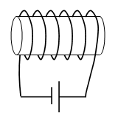

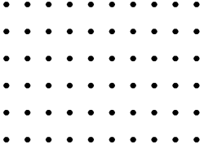


·
N
S
N
S

Question 2 (3 marks)
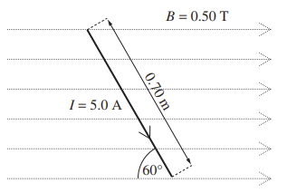
A current of 5.00 A flows in a wire that is placed in a magnetic field of 0.50 T. The wire is 0.70m long and is at an angle of 60º to the field.

- Calculate the magnitude of the force on the wire. [2]

- State the direction of the force on the wire. [1]

Question 3 (7 marks)
Two 5.00 m long parallel wires are separated by 0.20 m. Both wires have a current of 3.25 A flowing. The currents in the wires flow in opposite directions.

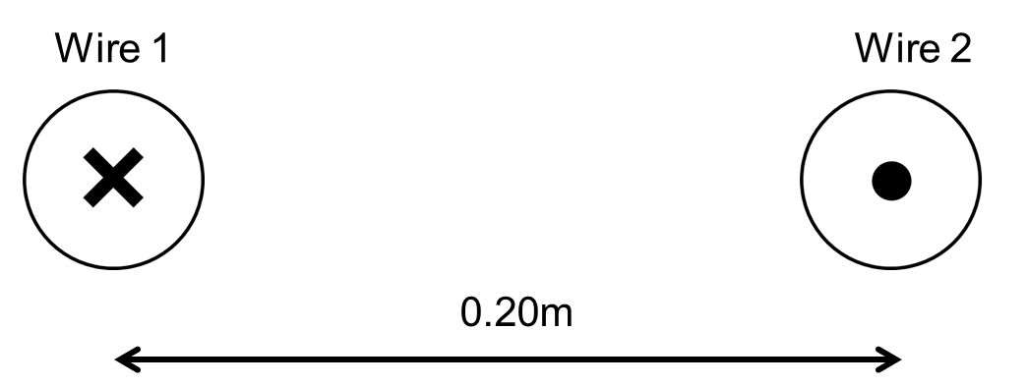

- Draw the magnetic field produced by the current flowing in Wire 2. Include at least 3 field lines. [2]

- Will the wires experience attraction, repulsion or no force while the currents are flowing?
Circle one option below. [1]

Attraction Repulsion No force

- Calculate the magnetic flux density at Wire 1 due to the current flowing in Wire 2. [2]

- Calculate the magnitude of the force applied to Wire 1 due to the current flowing in Wire 2.
[2]

Question 4 (4 marks)
A small magnet is moved towards a long solenoid as shown in the diagram below. The solenoid consists of 20 coils, each with an area of 1.23 x 10⁻³ m².

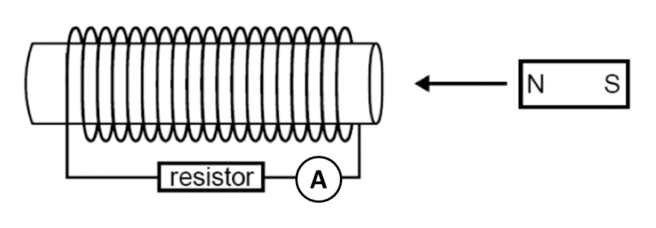

- Draw the direction of the induced current through the resistor as the magnet is moved towards the solenoid. [1]

- As the magnet approaches the solenoid, the magnetic field through the solenoid increases from 0.01 T to 0.04 T in 0.20 seconds. Calculate the magnitude of the induced emf in the solenoid. [2]

- The magnet is moved at a constant velocity through the solenoid until it leaves out the other side. Which graph best represents the ammeter readings over this time? [1]
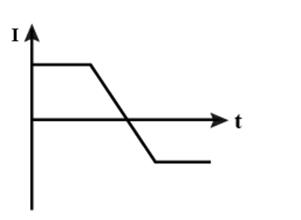
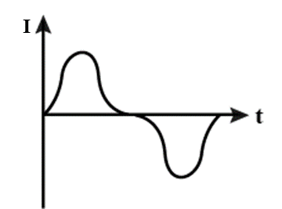

- ii)

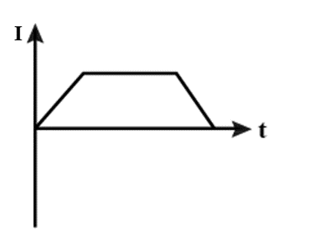
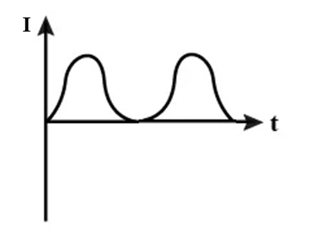
iii) iv)
Question 5 (4 marks)
Two small electrically charged spheres are hanging from the ceiling by non-conductive wires. Each sphere has a mass of 0.50 kg. The distance between the spheres is 4.00 cm. The charge of sphere P is -1.00 µC and the charge of sphere Q is +1.00 µC.

Calculate the angle θ that the wire supporting sphere P makes with the horizontal.

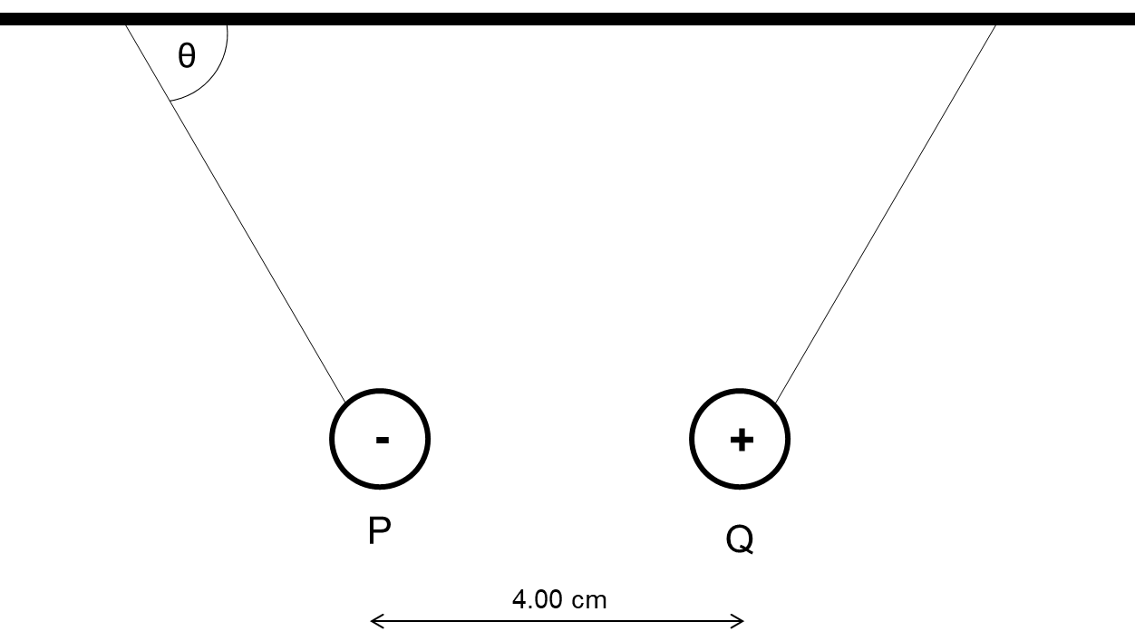

Question 6 (11 marks)
The DC motor below consists of a rectangular coil with a length of 55.0mm and a width of 350mm and 25 turns. A current of 2.20 A is passed through the coil. The magnets produce a magnetic field of 9.08 mT.

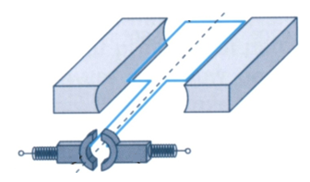
Part A

- Calculate the magnitude of the maximum torque produced by the motor. [3]

- What is the name and the purpose of the ‘Part A’ as shown on the diagram. [2]

- Complete the graph below to show how the torque varies as the motor is rotated 360º, starting at horizontal. [3]

𝜏
0° 90° 180° 270° 360°

- State three ways that the torque of the motor can be increased. [3]

1.

2.

3.

Question 7 (11 marks)
Nitrogen-14 ions (N³⁻) of mass 2.33 x 10⁻²⁶ kg and triple negative charge are accelerated from rest using the potential difference established between two parallel plates. The plates have a potential difference of 5000 V across of gap of 8.00 cm. Ignore the effects of gravity and air resistance for this question.

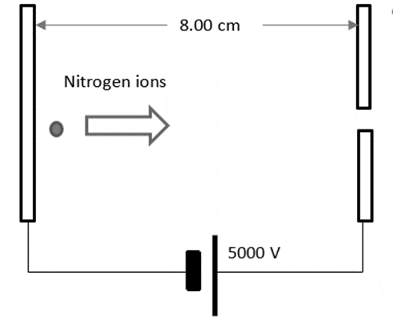

- Calculate the electric field strength between the parallel plates. [2]

- Calculate the magnitude of the electric force acting on the nitrogen ions. [2]

- Calculate the maximum speed reached by the nitrogen ions as leave through the small slit in the parallel plates. [3]

When the nitrogen ions leave the parallel plates, they are fed into a uniform magnetic field within a mass spectrometer. The magnetic field has a uniform flux density of 123 mT. The setup and the direction of the magnetic field is shown below.

If you did not calculate a value for (c), use 5.00 x 10⁵ ms⁻¹.

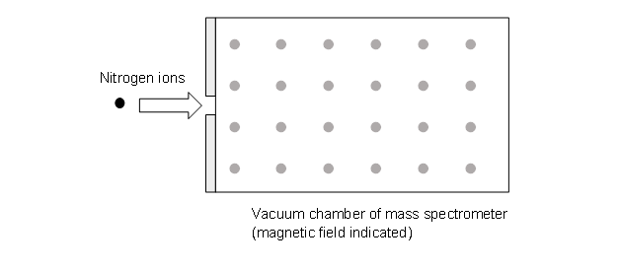

- Draw an arrow on the diagram above to show the general direction that the nitrogen ions would follow. [1]

- The force acting on the nitrogen ion due to the magnetic field will cause it to follow a circular path. By equating the magnetic force and the centripetal force, derive an expression to calculate the radius of the path taken by the nitrogen ion and evaluate the radius. [3]

Question 8 (9 marks)
A search coil is a specialised device that can be used to experimentally determine the magnetic flux density of a magnet. It consists of a very small, tightly wound coil attached to a voltmeter or oscilloscope. The search coil is moved inside the magnetic field and the induced emf is recorded.

A circular search coil of 5000 turns with a radius of 10.0 mm is used to determine the magnetic flux density of a large horseshoe magnet. The magnet has a uniform flux density between the two poles.

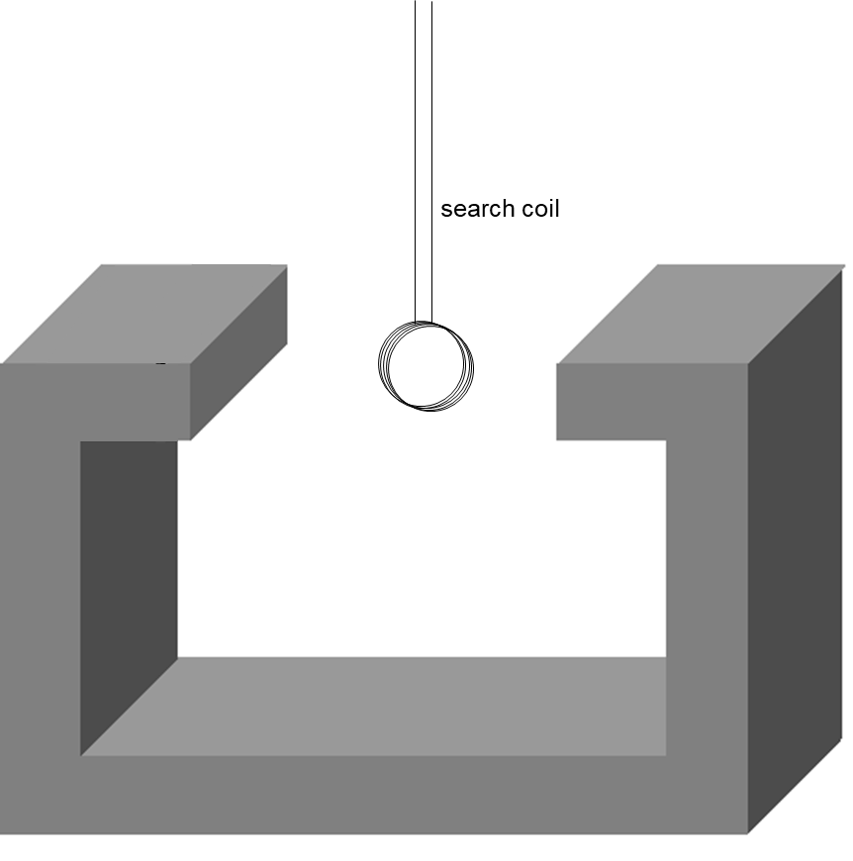

- The search coil is orientated such that the magnetic flux through the coil is maximised. The coil is then rotated at a constant speed. It rotates 180º in 0.10 s and a peak voltage of 16.7 V is recorded.

Calculate the magnetic flux density of the magnet. [3]

- Complete the graphs below to show the magnetic flux and the recorded emf as the search coil undergoes one full rotation, starting at maximum flux. [6]

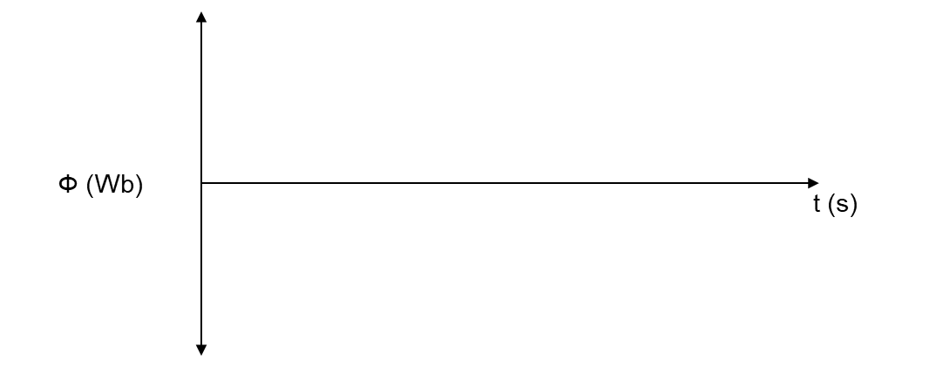

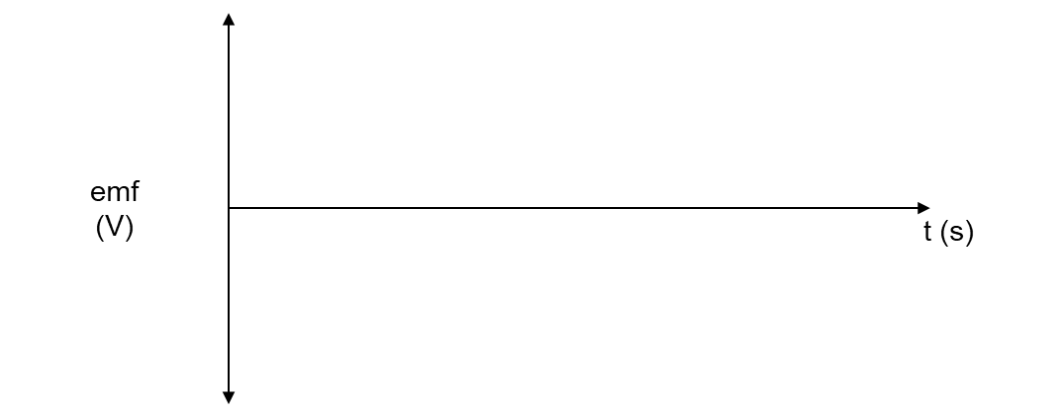

Question 9 (8 marks)
An aeroplane with a 15.0 m wingspan is flying North to South over the equator when it is instructed to change course to due East. It does this by executing a quarter-circle turn of radius 37.0 m. The Earth’s magnetic field at this location has a strength of 5.00 x 10⁻⁵ T.

The potential difference between the wingtips is measured as the plane executes the 90º turn and is shown in the table and graph below.

sin θ | ε (x10⁻³ volts)
0 | 0
0.2 | 3.10
0.4 | 5.40
0.6 | 8.65
0.8 | 10.9
1 | 14.4

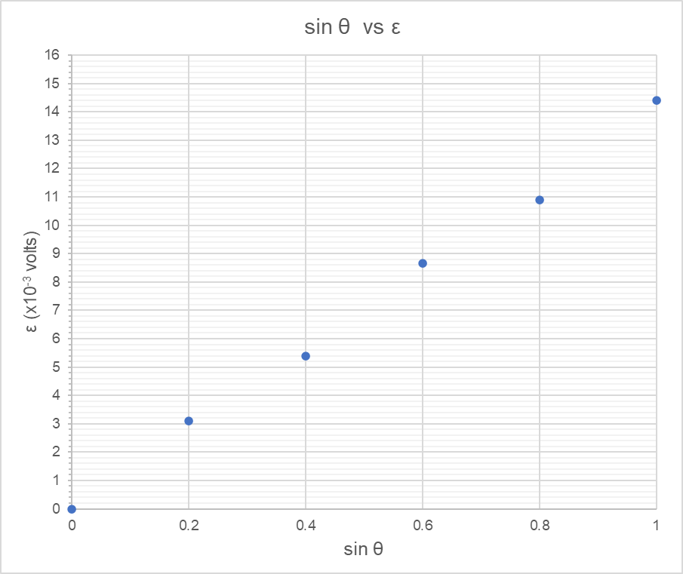
- Calculate the gradient of the line of best fit, showing all working. [3]

- Estimate the time taken for the plane to complete its turn. [5]

END OF TEST

